**Name: Aarya Tiwari  
Roll no.: 16010421119  
Batch: B2**

**Course: UIP**

**Experiment no. 4**

### MAIN PAGE :

### 

### Via this page, we can show the concepts of Single field inline edit, Multi field inline edit and Module Configuration.

**Single Field Inline Edit :**

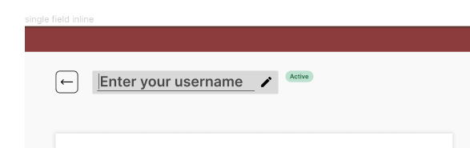

**Multi Field Inline Edit :**

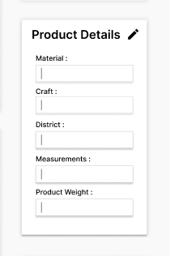 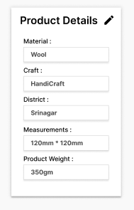

Here acknowledging the part of editing is must as user should know if the changes ae saved.  
Along with that making the edit noticeable to human is also equally important in both Single field and Multi field inline edits.

**Module Configuration:**

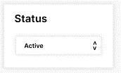

This section , represents the module configuration on our page, providing us to enable editing to multiple settings, as shown below.

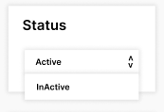

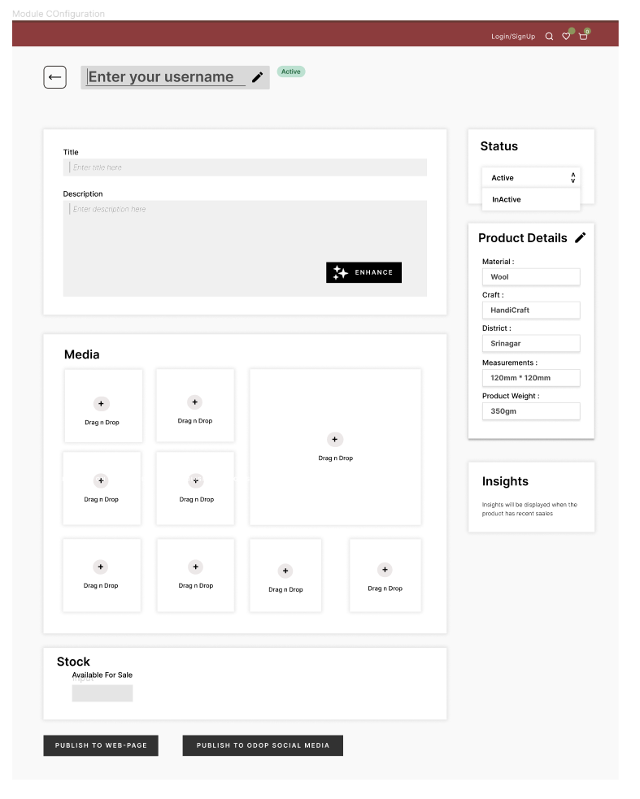

And when the status is changed to “INACTIVE” the following changes happen over the page.

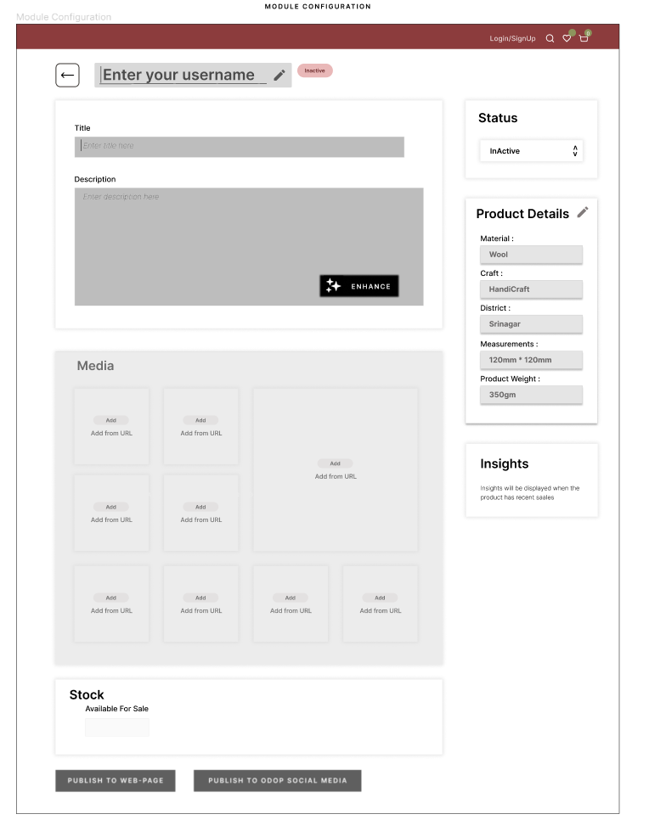

Disabling various parts that were previously editable.

**Outcomes:**

CO2: Apply principles of information organization and navigation along with data handling in

web interface design

**Conclusion:**

Thus, in this experiment we implemented a stay on page feature in it.